Flight Management Systems

- The FMS has become one of the key avionics systems because of the major reduction in pilot work load which is achieved by its use.
- In the case of military aircraft, they have enabled single crew operation of advanced strike aircraft.

Figure is a block diagram of a typical flight management system.

The benefits they confer are briefly set out below:
- Quantifiable economic benefits – provision of automatic navigation and flight path guidance to optimise the aircraft’s performance and hence minimise flight costs.
- Air traffic – growth of air traffic density and consequently more stringent ATC requirements, particularly the importance of 4D navigation.
- Accurate navigation sources – availability of accurate navigation sources. For example, INS /IRS, GPS, VOR, DME and ILS / MLS.
- Computing power – availability of very powerful, reliable, affordable computers.
- Data bus systems – ability to interconnect the various sub-systems.

The FMS carries out the following tasks:

1. Flight guidance and lateral and vertical control of the aircraft flight path.
2. Monitoring the aircraft flight envelope and computing the optimum speed for each phase of the flight and ensuring safe margins are maintained with respect to the minimum and maximum speeds over the flight envelope.
3. Automatic control of the engine thrust to control the aircraft speed.

Figure on the previous page shows the flight management system architecture of a modern airliner, in this case the Airbus A380.
- Two independent Flight Management Systems; FMS-1 on the Captain’s side and FMS-2 on the First Officer’s side carry out the flight management function.
- The cockpit interfaces to the flight crew provided by each FMS comprise a Navigation Display (ND), a Primary Flight Display (PFD), a Multi-Function Display (MFD), a Keyboard and Cursor Control Unit (KCCU) and an Electronic Flight Instrument System (EFIS) Control Panel (EFIS CP).
- The Multi-Function Display (MFD) displays textual data; over 50 FMS pages provide information on the flight plan, aircraft position and flight performance. The MFD is interactive; the flight crew can navigate through the pages and can consult, enter or modify the data via the Keyboard and Cursor Control Unit (KCCU).
- The Keyboard and Cursor Control Unit (KCCU) enables the flight crew to navigate through the FMS pages on the MFD and enter and modify data on the MFD, as mentioned above, and can also perform some flight plan revisions on the lateral Navigation Display (ND).
- The EFIS Control Panel (EFIS CP) provides the means for the flight crew to control the graphical and textual FMS data that appear on the ND and PFD.
- There are three Flight Management Computers; FMC-A, FMC-B and FMC-C to carry out the functional computations, which can be reconfigured to maintain the system operation in the event of failures.

There are three different FMS operating modes; Dual Mode, Independent Mode and Single Mode dependant on the system status.

Dual Mode

- Both flight management systems, FMS-1 and FMS-2, are healthy. Figure shows the configuration in normal operation in the left side illustration and the configuration after a single flight management computer failure in the right side illustration.
- In normal operation, FMC-A provides data to FMS-1, FMC-B provides data to FMC-2 and FMC-C is the standby computer.
- Of the two active computers, one FMC is the ‘master’ and the other is the ‘slave’, depending on which autopilot is active and the selected position of the FMS Source Select Switch.
- The two active FMCs independently calculate data, and exchange, compare and synchronise these data. The standby computer does not perform any calculations, but is regularly updated by the master FMC.
- In the case of a single FMC failure, for example FMC-A, FMC-C provides data to FMS-1. as shown in the right side illustration in Figure.

IndependentMode
In the Independent Mode, FMS-1 and FMS-2 are both operative, but there is no data exchange between them because they disagree on one or more items such as aircraft position, gross weight, etc. This case is shown in the left side illustration in Figure.

Single Mode
The loss of two FMC’s causes the loss of either FMS-1 or FMS-2. The data from the operative FMS is displayed to the flight crew by operating the Source Select Switch. This case is shown in the right side illustration in Figure.

Radio Navigation Tuning
- The FMS automatically tunes the radio navigation aids, (NAVAIDs), used for the radio position computation, the NAVAIDS for display on the Navigation Displays and the landing system NAVAIDS. In ‘Dual’ and ‘Independent’ modes each FMS tunes its onside NAVAIDS.
- These comprise, in the case of the A380, one VOR, four DMEs, one ILS (MLS/GLS optional), one ADF (optional).
- In ‘Single’ FMS mode, or in the case of a communications failure between an FMS and its onside Radio Management Panel (RMP), the available FMS will tune the NAVAIDS on both sides.
- The tuning of the onside NAVAIDS passes through the onside RMP, to synchronise the NAVAIDS tuning between the FMS and the RMP.
- The A380 FMS radio navigation tuning system is shown in Figure together with the ‘POSITION/ NAVAIDS Page’ display on the Multi-Function Display.
- The NAVAIDS displayed on the Navigation Displays and the landing system NAVAIDS can also be tuned manually on the ‘POSITION/NAVAIDS’ Page of the MFD, or on the Radio Management Panel. Manual tuning always has priority over automatic tuning.

Navigation
- The FMS combines the data from the navigational sources, comprising the inertial systems, GPS and the radio navigation systems, in a Kalman filter to derive the best estimate of the aircraft position. The accuracy of this estimate is also evaluated.
- Figure is a block diagram of the Kalman filtering of the navigational sources . Each FMS computes the aircraft position and the position accuracy.
- The FMS computed position is an optimum combination of the inertial position and the GPS or radio position, depending on which equipment provides the most accurate data.

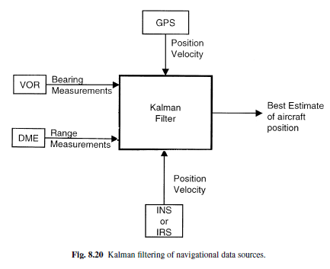

This results in four navigation modes in decreasing order of priority:
• Inertial (IRS) – GPS.
• Inertial (IRS) – DME/DME.
• Inertial (IRS) – VOR/DME.
• Inertial (IRS) only.
- The FMS aircraft position always uses the inertial position. This computation is not possible if the inertial position is not valid, and in this case all the FMS navigation and flight planning functions are no longer available.
- The FMS continually computes the Estimated Position Uncertainty (EPU), and the EPU is used, together with the Required Navigation Performance (RNP,) to define the aircraft navigation accuracy.
The FMS continuously compares the actual EPU with the current RNP, and defines the navigation class as:
• HIGH, if the EPU is less than, or equal to the RNP.
• LOW, if the EPU is greater than the RNP.
- The navigation class has to satisfy the Airworthiness Authorities Accuracy Requirements (AAAR). The FMS computes ground speed, track, wind direction and velocity. (It should be noted that the air data system provides the height information for vertical navigation.) As stated earlier, the FMS provides both lateral and vertical guidance signals to the autopilot to control the aircraft flight path. In the lateral case, the FMS computes the aircraft position relative to the flight plan and the lateral guidance signals to capture and track the flight path specified by the flight plan. Three-dimensional vertical guidance is provided to control the vertical flight profile including the time dimension as will be explained in more detail later. This is of particular benefit during the descent and approach.

Flight Planning
As explained earlier, a major function of an FMS is to help the flight crew with flight planning and it contains a database of:
• Radio NAVAIDS – VOR, DME, VORTAC, TACAN, NDB, comprising identification, latitude/longitude, altitude, frequency, magnetic variation, class, airline figure of merit.
• Waypoints – usually beacons.
• Airways – identifier, sequence number, waypoints, magnetic course.
• Airports – identifier, latitude, longitude, elevation, alternative airport.
• Runways – length, heading, elevation, latitude, longitude.
• Airport procedures – ICAO code, type, SID, STAR, ILS, profile descent.
• Company routes – original airport, destination airport, route number, type, cruise altitudes, cost index.
The navigation data base is updated every 28 days, according to the ICAO AiRAC cycle, and is held in non-volatile memory. It is clearly essential to maintain the recency and quality of the data base and the operator is responsible for the detail contents of the data base which is to ARINC 424 format.

Control of the Vertical Flight Path Profile
The FMS selects the speeds, altitudes and engine power settings during climbs, cruises and descents taking into account the flight plan, the prevailing conditions and the optimisation of the operation of the aircraft.
The vertical definition of a typical flight plan is shown in Figure.

The tasks which can be carried out and the facilities provided by the FMS during the various phases of the flight are briefly summarised below:
• TAKE OFF – The critical speeds V1, VR, and V2 are inserted by the crew and displayed on the primary flight displays.
• CLIMB – The FMS uses the manually input speed, the ATC constraint speed or the economical speed. It determines the start of the climb during take-off and predicts the end of the climb and the optimum cruising flight level.
• CRUISE – Five flight levels can be defined manually in the FMS. Two flight levels can be stored for every route in the navigation data base. During the cruise, ATC or the crew may change the cruise altitude and the FMS can perform a ‘step’ climb at economical speed or a ‘step’ descent at 1000 ft/min at an economical speed. These events are also displayed symbolically on the navigation display.
• DESCENT – The FMS uses the manually input speed, the ATC constraint speed or the economic speed. The altitude and speed during the descent are computed as a function of the distance to the destination and a geometric profile is formed. The flight path is then computed backwards to satisfy the constraints.
• APPROACH – The FMS can be coupled to the autopilot or alternatively provide guidance information to the pilot for manual control of the aircraft. Speed is critical during this phase and the approach speed is computed with
respect to VREF and the landing configuration (flaps, slats, etc.) and the wind at the destination. The approach mode is entered at the end of the descent and the approach ends either with landing or go around. Lateral guidance is provided by the FMS from the computed aircraft position and vertical guidance from barometric altitude
when an RNAV approach has been selected. The FMS also provides speed control. At the end of an RNAV approach the crew takes control to carry out the landing using visual references. When an ILS approach has been selected, the FMS tunes the ILS frequency and selects the runway heading as required for the runway selected by the crew. The approach and landing guidance is carried out by the autopilot using the ILS localiser references for horizontal guidance and the ILS glide slope references for the vertical guidance until the glide extension
and flare phases, unless the crew elect to carry out an automatic go around or elect to take over control.
• GO AROUND – This is always assumed. The FMS manages the climb to the accelerating altitude or a selected altitude and provides track guidance from the outbound track defined in the flight plan.

Operational Modes
The FMS provides a number of very useful operational modes which are shown in the little sketches in Figures (a)–(d).
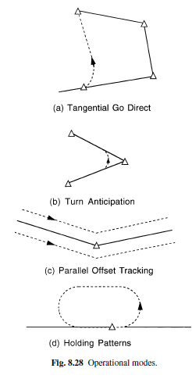

Tangential go direct to mode – This is shown in Figure (a) and provides navigation from the current position to any waypoint in the flight plan or entered during the flight.
• Turn anticipation – This is shown in Figure (b) and avoids overshooting waypoints. It reduces both the distance flown and off-track manoeuvring.
• Parallel offset tracking – This is illustrated in Figure(c). The lateral offset allows ATC to increase traffic flows in certain cases.
• Holding pattern – This is illustrated in Figure(d). The FMS produces a precision holding pattern based on published ICAO entry procedure to reduce the pilot work load.

Typical avionics sub systems or various layers of avionics systems or Systems Which Interface Directly with the Pilot

Display Systems
- Provide the visual interface between the pilot and the aircraft systems and comprise head up displays (HUDs), helmet mounted displays (HMDs) and head down displays (HDDs).
- The prime advantages of the HUD and HMD are that they project the display information into the pilot’s field of view so that the pilot can be head up and can concentrate on the outside world.
- The HUD now provides the primary display for presenting the essential flight information to the pilot and in military aircraft has transformed weapon aiming accuracy.
- The HUD can also display a forward looking infrared (FLIR) video picture one to one with the outside world from a fixed FLIR imaging sensor installed in the aircraft.
- The infrared picture merges naturally with the visual scene enabling operations to be carried out at night or in conditions of poor visibility due to haze or clouds.
- The HMD enables the pilot to be presented with information while looking in any direction, as opposed to the limited forward field of view of the HUD.

Communications Systems
- The need for reliable two way communication between the ground bases and the aircraft or between aircraft is self evident and is essential for air traffic control.
- Long range communication is provided by high frequency (HF) radios operating in the band 2–30 MHz.
- Near to medium range communication is provided in civil aircraft by very high frequency (VHF) radios operating in the band 30–100 MHz
- Military aircraft by ultra high frequency (UHF) radio operating in the band 250–400 MHz. Equipmentis usually at duplex level of redundancy
- The VHF radios are generally at triplex level on a modern airliner.
- Satellite communications (SATCOM) systems are also installed in many modern aircraft and these are able to provide very reliable world wide communication.
Data Entry and Control Systems
- Are essential for the crew to interact with the avionic systems. Such systems range from keyboards and touch panels to the use of direct voice input (DVI) control, exploiting speech recognition technology, and voice warning systems exploiting speech synthesisers.
Flight Control Systems
- Exploit electronic system technology in two areas, namely auto-stabilisation (or stability augmentation) systems and FBW flight control systems.
- Most swept wing jet aircraft exhibit a lightly damped short period oscillatory motion about the yaw and roll axes at certain height and speed conditions, known as ‘Dutch roll’, and require at least a yaw auto-stabiliser system to damp and suppress this motion; a roll auto-stabiliser system may also be required.
- Most combat aircraft and many civil aircraft in fact require three axis auto-stabilisation systems to achieve acceptable control and handling characteristics across the flight envelope.
- FBW flight control enables a lighter, higher performance aircraft to be produced compared with an equivalent conventional design by allowing the aircraft to be designed with a reduced or even negative natural aerodynamic stability.
- The system can be designed to provide excellent control and handling characteristics across the flight envelope. ‘Care free manoeuvring’ characteristics can also be achieved
- A very high integrity, failure survival system is of course essential for FBW flight control.
Aircraft State Sensor Systems
(a)Air Data Systems
- Provide accurate information on the air data quantities that is the altitude, calibrated airspeed, vertical speed, true airspeed, Mach number and airstream incidence angle.
- This information is essential for the control and navigation of the aircraft.
- The air data computing system computes these quantities from the outputs of very accurate sensors which measure the static pressure, total pressure and the outside air temperature.
- The air-stream incidence angle is derived from air-stream incidence sensors.
(b)Inertial Sensor Systems
- Provide the information on aircraft attitude and the direction which is essential information for the pilot in executing a manoeuvre or flying in conditions of poor visibility, flying in clouds or at night.
- Accurate attitude and heading information are also required by a number of avionic sub-systems which are essential for the aircraft’s mission – for example, the autopilot and the navigation system and weapon aiming in the case of a military aircraft.
- The attitude and heading information is provided by the inertial sensor system(s). These comprise a set of gyros and accelerometers which measure the aircraft’s angular and linear motion about the aircraft axes, together with a computing system which derives the aircraft’s attitude and heading from the gyro and accelerometer outputs.
- The INS is completely self-contained and does not require any access to the outside world.
Navigation Systems
- Accurate navigation information, that is the aircraft’s position, ground speed and track angle (direction of motion of the aircraft relative to true North) is clearly essential for the aircraft’s mission, whether civil or military.
- Navigation systems can be divided into dead reckoning (DR) systems and position fixing systems; both types are required in the aircraft.
(a)Dead Reckoning Navigation Systems
- Derive the vehicle’s present position by estimating the distance travelled from a known position from knowledge of the speed and direction of motion of the vehicle. They have the major advantages of being completely self contained and independent of external systems.
- The main types of DR navigation systems used in aircraft are:
(a) Inertial navigation systems. The most accurate and widely used systems.
(b) Doppler/heading reference systems. These are widely used in helicopters.
(c) Air data/heading reference systems These systems are mainly used as a reversionary navigation system being of lower accuracy
- A characteristic of all DR navigation systems is that the position error builds up with time.
(b)Position Fixing Systems
- Used are now mainly radio navigation systems based on satellite or ground based transmitters. A suitable receiver in the aircraft with a supporting computer is then used to derive the aircraft’s position from the signals received from the transmitters. The prime position fixing system is without doubt GPS (global positioning system).
- There are also radio navigation aids such as VOR/DME and TACAN which provide the range and bearing (R/θ) of the aircraft.
- Approach guidance to the airfield/airport in conditions of poor visibility is provided by the ILS (instrument landing system), or by the later MLS (microwave landing system).
Outside World Sensor Systems
- These systems, which comprise both radar and infrared sensor, systems enable all weather and night time operation and transform the operational capability of the aircraft (or helicopter).
(a)Radar Systems
- Installed in civil airliners and many general aviation aircraft provide weather warning. The radar looks ahead of the aircraft and is optimised to detect water droplets and provide warning of storms, cloud turbulence and severe precipitation so that the aircraft can alter course and avoid such conditions, if possible.
- These radars can also generally operate in ground mapping and terrain avoidance modes.
- Modern fighter aircraft generally have a ground attack role as well as the prime interception role and carry very sophisticated multi-mode radars to enable them to fulfil these dual roles.
- In the airborne interception (AI) mode, the radar must be able to detect aircraft up to 100 miles away and track while scanning and keeping tabs on several aircraft simultaneously (typically at least 12 aircraft). The radar must also have a ‘look down’ capability and be able to track low flying aircraft below it.
- In the ground attack or mapping mode, the radar system is able to generate a map type display from the radar returns from the ground, enabling specific terrain features to be identified for position fixing and target acquisition.
(b)Infrared Sensor Systems
- Have the major advantage of being entirely passive systems.
- Infrared (IR) sensor systems can be used to provide a video picture of the thermal image scene of the outside world.
- The thermal image picture at night looks very like the visual picture in daytime, but highlights heat sources, such as vehicle engines, enabling real targets to be discriminated from camouflaged decoys.
- FLIR systems can also be installed in civil aircraft to provide enhanced vision in poor visibility conditions in conjunction with a HUD.
Task Automation Systems
- These comprise the systems which reduce the crew workload and enable minimum crew operation by automating and managing as many tasks as appropriate so that the crew role is a supervisory management one.
(a)Navigation Management
- Comprises the operation of all the radio navigation aid systems and the combination of the data from all the navigation sources, such as GPS and the INS systems, to provide the best possible estimate of the aircraft position, ground speed and track.
- The system then derives the steering commands for the autopilot so that the aircraft automatically follows the planned navigation route. It should be noted that this function is carried out by the flight management system (FMS) (if installed).
(b)Autopilots and FlightManagement Systems
- It has been grouped together. Because of the very close degree of integration between these systems on modern civil aircraft.
- It should be noted, however, that the Autopilot is a ‘stand alone’ system and not all aircraft are equipped with an FMS.
- The autopilot relieves the pilot of the need to fly the aircraft continually with the consequent tedium and fatigue and so enables the pilot to concentrate on other tasks associated with the mission.
- a suitably designed high integrity autopilot system can also provide a very precise control of the aircraft flight path for such applications as automatic landing in poor or even zero visibility conditions.
- In military applications, the autopilot system in conjunction with a suitable guidance system can provide automatic terrain following, or terrain avoidance.
The tasks carried out by the FMS include:
• Flight planning.
• Navigation management.
• Engine control to maintain the planned speed or Mach number.
• Control of the aircraft flight path to follow the optimised planned route.
• Control of the vertical flight profile.
• Ensuring the aircraft is at the planned 3D position at the planned time slot
Flight envelope monitoring.
• Minimising fuel consumption.
(c)Engine Control and Management Systems
- Carry out the task of control and the efficient management and monitoring of the engines.
- Many modern jet engines have a full authority digital engine control system (FADEC). This automatically controls the flow of fuel to the engine combustion chambers by the fuel control unit.
- The control system ensures the engine limits in terms of temperatures, engine speeds and accelerations are not exceeded and the engine responds in an optimum manner to the throttle command.
- A FADEC engine control system is thus similar in many ways to a FBW flight control system.
- Other very important engine avionic systems include engine health monitoring systems which measure, process and record a very wide range of parameters associated with the performance and health of the engines. These give early warning of engine performance deterioration, excessive wear, fatigue damage, high vibration levels, excessive temperature levels, etc.
(d)House Keeping Management
- To cover the automation of the background tasks which are essential for the aircraft’s safe and efficient operation.
Such tasks include:
• Fuel management. This embraces fuel flow and fuel quantity measurement and control of fuel transfer
from the appropriate fuel tanks to minimise changes in the aircraft trim.
• Electrical power supply system management.
• Hydraulic power supply system management.
• Cabin/cockpit pressurisation systems.
• Environmental control system.
• Warning systems.
• Maintenance and monitoring systems.
Need of avionics in civil, military and spacecraft

Civil Aircraft

- The avionics industry is a major multi-billion dollar industry world-wide.
- The avionics equipment on a modern military or civil aircraft can account for around 30% of the total cost of the aircraft.
- This figure for the avionics content is more like 40% in the case of a maritime patrol/anti-submarine aircraft (or helicopter) and can be over 75% of the total cost in the case of an airborne early warning aircraft (AWACS).
- Modern general aviation aircraft also have significant avionics content. For example, colour head down displays, GPS satellite navigation systems, radio communications equipment. Avionics can account for 10% of their total cost.
- The avionic systems are essential to enable the flight crew to carry out the aircraft mission safely and efficiently, whether the mission is carrying passengers to their destination in the case of a civil airliner, or, in the military case, intercepting a hostile aircraft, attacking a ground target, reconnaissance or maritime patrol.
- A major driver in the development and introduction of avionic systems has been the need to meet the mission requirements with the minimum flight crew.
- In the case of a modern civil airliner, this means a crew of two only, namely the First Pilot (or Captain) and the Second Pilot.
- This is only made possible by reducing the crew workload by automating the tasks which used to be carried out by the Navigator and Flight Engineer.
- The achievement of safe two crew operation has very considerable economic benefits for the airline in a highly competitive market with the consequent saving of crew salaries, expenses and training costs.
- The reduction in weight is also significant and can be translated into more passengers or longer range on less fuel.
- In the military case, a single seat fighter or strike (attack) aircraft is lighter and costs less than an equivalent two seat version.
- The elimination of the second crew member (Navigator/Observer/Radar Operator) has also significant economic benefits in terms of reduction in training costs
- Other very important drivers for avionic systems are increased safety, air traffic control requirements, all weather operation, reduction in fuel consumption, improved aircraft performance and control and handling and reduction in maintenance costs.
- The Air Traffic Control (ATC) transponder system, the Ground ProximityWarning System (GPWS) and the Threat Alert/Collision Avoidance System (TCAS), all of which are mandatory
equipment for civil airliners.
- GPWS provides warning by means of a visual display and audio signal (‘Pull up, Pull up . . . ’) that the aircraft is on a flight path that will result in flying into the terrain, and that action must be taken to change the flight path.
- TCAS provides an alerting and warning display of other aircraft in the vicinity in terms of their range, course and altitude together with advisory collision avoidance commands.

Military Aircraft

Weapon Management:
- Fire control to calculate lead angle for aiming guns and unguided rockets at other aircraft and at ground target.
- Stores management that initializes and launches guided weapons: Missile and Bombs.
Electronic Counter Measure (ECM):
- This subsystem detects, locates and identifies enemy emitters of electromagnetic radiation.
- It may also generate jamming sgnals.
Mission Planning:
- Pre-flight mission planning is usually done at the airbase by a computer that prepares coordinated flight plans for an entire squadron.
- On-board software replans routes through enemy defenses based on en-route observation.
- Enroute replanning requires on-board digital maps of the terrain and real time detection of enemy radars.
- The military uses radar in fast jets to help pilots fly at low levels.
- Electro-Optic Systems(EOS) include forward looking infrared (FLIR), and passive infrared devices (PIDS) are used to provide imagery to crews.
- This image is used for everything from search and rescue through to acquiring better resolution on a target.
- Electronic Support Measure (ESM) and Defensive Aids (DAIDS) are used extensively to gather information about threats or possible theats. They can be used to launch devices to counter direct threats against the aircraft.
Air Superiority
- The primary aim of this role is to deny to an enemy the airspace over the battlefield, thus allowing ground attack aircraft a free rein in destroying ground targets and assisting ground forces, secure in the knowledge that the airborne threat has been suppressed.
- The air superiority aircraft is typically designed to enable the pilot to respond rapidly to a deployment call, climb to intercept or loiter on combat air patrol (CAP) and then to engage enemy targets, preferably beyond visual range.
- The aircraft should also have the capability to engage in close combat, or dogfight,with other aircraft should this prove to be necessary.
- The systems must allow for accurate navigation, accurate identification of targets, prioritisation of targets, accurate weapon aiming capability and the ability to join the tactical communications network
Ground Attack
- The ground attack role has been developed to assist the tactical situation on the battlefield.
- The pilot must be able to identify the right target among the ground clutter and multiplicity of targets and friendly units on the battlefield.
- The ability to designate targets by laser has enabled precision bombing to be adopted by the use of laser-guided bombs or ‘smart’ bombs.
- The role must enable fixed targets such as buildings, radar installations and missile sites, as well as mobile targets such as tanks, guns, convoys, ships and troop formations, to be detected, positively identified and engaged
Strategic Bomber
- The role of the strategic bomber is to penetrate deep into enemy territory and to carry out strikes that will weaken defences and undermine the morale of the troops.
- The strategic bomber was usually a very high-flying aircraft capable of carrying a large load of bombs which were released in a ‘carpet bombing’ pattern.
- The modern aircraft may choose to fly low and fast and rely on stealth to evade enemy radar defences.

Protocol
The rules under which the transfers occur is referred to as “protocol”. The control, data flow, status reporting, and management of the bus is provided by three word types.
1.3.1 Word Types
- Three distinct word types are defined by the standard. These are command words, data words, and status words. Each word type has a unique format yet all three maintain a common structure. Each word is 20 bits in length.

COMMAND WORD (CW):

Command Synchronization (bit times 1-3)
- Specifies the function that a remote terminal(s) is to perform. This word is only transmitted by the active bus controller. The word begins with command sync in the first three bit times.
Terminal Address (TA) field (bit times 4–8)
- States to which unique remote terminal the command is intended (no two terminals may have the same address).
- Note that an address of 00000 is a valid address, and that an address of 11111 is reserved for use as the broadcast address.
- The maximum number of terminals the data bus can support is 31.
- an open circuit on an address line is detected as a logic “1,”
- connecting an address line to ground is detected as a logic “0,”
Transmit/Receive (T/R) bit(bit time 9)
- This defines the direction of information flow and is always from the point of view of the remote terminal.
- A transmit command (logic 1) indicates that the remote terminal is to transmit data,
- Receive command (logic 0) indicates that the remote terminal is going to receive data. The only exceptions to this rule are associated with mode commands.
Subaddress (SA)/Mode Command (MC) bits(bit times 10–14)
- Logic 00000 or 11111 within this field shall be decoded to indicate that the command is a Mode Code Command.
- All other logic combinations of this field are used to direct the data to different functions within the subsystem.
Word Count (WC) or Mode Code (bit times 15–19)
- If the Subaddress/Mode Code field was 00000 or 11111, then this field defines the mode code
to be performed.
- If not a mode code, then this field defines the number of data words either to be received
or transmitted depending on the T/R bit.
Parity bit (bit Time 20).
- Only odd parity shall be used.
DATA WORD:
- The Data Word (DW) contains the actual information that is being transferred within a message. Data words can be transmitted by either a remote terminal (transmit command) or a bus controller (receive command).
- The first three bit times contain data sync.
- This sync pattern is the opposite of that used for command and status words and therefore is unique to the data word type.
- The following 16 bits of information are left to the designer to define.
- The only standard requirement is that the most significant bit (MSB) of the data be transmitted first.
- The last bit (bit time 20), is the word parity bit. Only odd parity shall be used.
STATUS WORD:
- The Status Word (SW) is only transmitted by a remote terminal in response to a valid message. The status word is used to convey to the bus controller whether a message was properly received or the state of the remote terminal (i.e., service request, busy, etc.).
- Terminal Address (bit times 4–8) these five bits should match the corresponding field within the command word that the terminal received. The remote terminal sets these bit to the address to which it has been programmed.
- Message Error (bit time 9) This bit is set to a logic “1” by the remote terminal upon detection of a error in the message or upon detection of an invalid message (i.e., Illegal Command) to the terminal.
- Instrumentation bit (bit time 10) is provided so as to differentiate between a command word and a status word (remember, they both have the same sync pattern). The instrumentation bit in the status word is always set to logic “0.” If used, the corresponding bit in the command word is set to a logic “1.”
- Service Request. bit (bit time 11) is such that the remote terminal can inform the bus controller that it needs to be serviced. This bit is set to a logic “1” by the subsystem to indicate that servicing is needed. It can take a predetermined action such as issuing a series of messages, or it can request further data from the remote terminal as to its needs.
- Reserved. Bit times 12–14 are reserved for future growth of the standard and must be set to a logic
“0.” The bus controller should declare a message in error if the remote terminal responds with any of
these bits set in its status word.
- Broadcast Command Received bit (bit time 15) indicates that the remote terminal received a valid broadcast command. Upon receipt of a valid broadcast command, the remote terminal sets this bit to logic “1” and suppresses the transmission of its status words. The bus controller may issue a Transmit Status Word or Transmit Last Command Word Mode Code to determine if the terminal received the message properly.
- Busy bit (bit time 16) is provided as a feedback to the bus controller as to when the remote
terminal is unable to move data between the remote terminal electronics and the subsystem in compliance to a command from the bus controller.
- Subsystem Flag bit (bit time 17) is used to provide “health” data regarding the subsystems to which the remote terminal is connected. This single bit is only to serve as an indicator to the bus controller and user of the data that a fault or failure exists
- Dynamic Bus Control Acceptance bit (bit time 18) is used to inform the bus controller that the remote terminal has received the Dynamic Bus Control Mode Code and has accepted control of the bus.
- Terminal Flag bit (bit time 19) is used to inform the bus controller of a fault or failure within the remote terminal circuitry (only the remote terminal). A logic “1” shall indicate a fault condition.
- Parity. The last bit (bit time 20), is the word parity bit. Only odd parity shall be used.
Message Formats, Validation, and Timing
- The primary purpose of the data bus is to provide a common medium for the exchange of data between systems. The exchange of data is based upon message transmissions.
- The standard defines 10 types of message transmission formats.
- The message formats have been divided into two groups “information transfer formats” and the “broadcast information transfer formats”

FIGURE 1.6 Information transfer formats

FIGURE 1.7 Broadcast information transfer formats.

- Broadcast messages are transmitted to multiple remote terminals at the same time. As such, the
terminals suppress the transmission of their status words.
Bus Controller to Remote Terminal
- The bus controller to remote terminal (BC-RT) message is referred to as the receive command since the remote terminal is going to receive data.
- The bus controller outputs a command word to the terminal defining the sub address of the data and the number of data words it is sending. Immediately (without any gap in the transmission), the number of data words specified in the command word are sent.
- The remote terminal upon validating the command word and all of the data words will issue its status word within the response time requirements (maximum of 12 _sec).
Remote Terminal to Bus Controller
- The remote terminal to bus controller (RT-BC) message is referred to as a transmit command.
- The bus controller issues only a transmit command word to the remote terminal.
- The terminal, upon validation of the command word, will first transmit its status word followed by the number of data words requested by the command word.
- Since the remote terminal does not know the sequence of commands to be sent and does not normally operate upon a command until the command word has been validated.

Remote Terminal to Remote Terminal
- The remote terminal to remote terminal (RT-RT) command is provided to allow a terminal (the data source) to transfer data directly to another terminal (the data sink) without going through the bus controller.
- The bus controller may, however, collect and use the data. The bus controller first issues a command word to the receiving terminal immediately followed by a command word to the transmitting terminal.
- The receiving terminal is expecting data, but instead of data after the command word it sees a command sync (the second command word).
- The receiving terminal ignores this word and waits for a word with a data sync.
- The transmitting terminal ignored the first command word (it did not contain its terminal address).
- The second word was addressed to it, so it will process the command as an RT-BC command as described above by transmitting its status word and the required data words.
- The receiving terminal, having ignored the second command word, again sees a command (status) sync on the next word and waits further.
- The next word (the first data word sent) now has data sync and the receiving remote terminal starts collecting data. After receipt of all of the data words (and validating), the terminal transmits its status word.

UNIT - V

1. Explain the operation of inertial navigation system (INS)
To navigate initially
- We first measure the acceleration in the directions of the navigation axes, and if our instruments are not perfect, we might compensate their readings by removing biases or scale factor errors.
- Second, to find the vehicles vertical acceleration, we subtract gravity from the “Down” accelerometer output.
- Third, we integrate the accelerations over a known time, once to get the velocity, twice to get the distance travelled. For periods of constant acceleration we can apply the “equation of motion” to find the distance travelled, (s):
v = u + at (1)
s = ut + 1/2at² (2)
Where
a = acceleration
v = velocity after time t
u = initial velocity
- Fourth, we measure the rotation rates either from gimbal motions in a stabilized platform or directly with gyroscopes in a strap down system. We then compensate for gyro bias and possibly scale factor errors, and we determine a new heading.
- Fifth, we compensate for earth’s rotation if we are in local level axes; otherwise the platform would be space stabilized and would appear to tilt in the vehicle axes set.
- Finally, the combined distance and heading data give us an updated dead reckoned position to display.
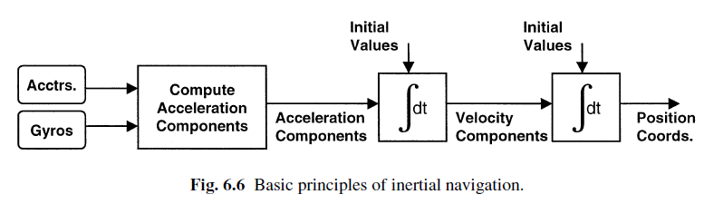
2. Explain the operation of Stable platform and strap down platform INS:
Stable platform INS:
“The inertial sensors might be mounted in a set of gimbals so that they stay level and head in a fixed direction no matter how the vehicle moves. This construction is called stable platform INS.”
- The stable platform uses gyros to maintain the accelerometers in a fixed attitude.
- A single axis platform consists of a gyro mounted so that its sensing axis or input axis is along the axis of the platform, which is set into the vehicle bearings.
- Electrical power for the gyro comes in and gyro’s output goes out, through slip rings.
- The platform can be driven around its axis by an electric torque motor.
- The gyro output drives the torque motor through servo amplifier.
- The servo amplifier provides the torque to overcome the friction in the slip rings and bearings.
- If the platform had no gyro and the vehicle rotated around the platform axis, the platform inertial would tend to keep the platform aligned in space.
- But the platform would slowly accelerate due to the torque transmitted through the bearings and slip rings, and the inertial reference would be lost.
- By adding the gyro, we sensing any platform rotation with respect to inertial space, down to the limit of the gyro’s resolution.
- The gyro only used to maintain a fixed position (null operation) and does not able to measure larger rotation rates.
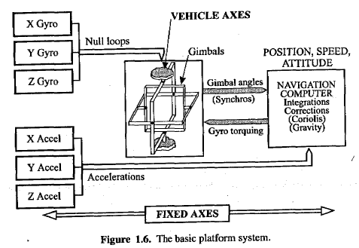
Gimbal Lock:
The gimbal lock can be caused by a set of aircraft movements that cause two of the
Advantages:
- Simpler Gyro
- Higher Accuracy
- Self Alignment by Gyro Compassing
- sensor calibration by Platform Rotations
Disadvantages:
- Complexity and Cost
- Gimbals Magnetic
- Low Reliability

Explain the operation of Strap Down platform INS:
“The inertial sensors might be attached to the vehicle, and the system computes direction traveled in the reference axes by transforming the measurements from the vehicle axes to the reference axes.”
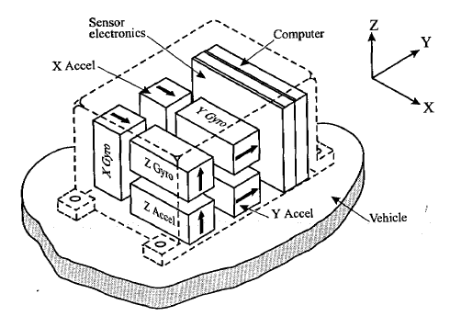
- The strap down system replaces gimbals with a computer.
- In the strap down system the gyroscope and accelerometers are rigidly mounted to the vehicle structure so that they move with vehicle.
- Now the strap down gyros must measure the angles turned, up to the maximum rotation rate expected.
- Airplanes can experience short term rates up to 400 deg/s, so a gyro with 0.01 deg/h performance has a dynamic range of 10⁸
- As the vehicle travels, the gyro measure the yaw, pitch, and roll angles turned in a short time (say 0.01s) and pass them to a computer that uses them to resolve the accelerometer outputs into the navigation axes set.
- Simplifying to two dimensions, we can easily express the coordinate transformation between the navigation axis set (x_{nav}, y_{nav}) and the body axis set (x_{body}, y_{body}) at a time when the z-axis gyro has measured that there is angle θ between them.
- The accelerometers fixed in the body axes record accelerations a_{x}, a_{y}.
- Converting to navigation axes we get
(a_{x}) _{nav} = a_{x} cosθ – a_{y} sin θ (1)
(a_{y}) _{nav} = a_{x} sinθ + a_{y} cosθ (2)
- When adding the third (z) axis we must use more complicated transformations because the rotations are non-communicative.
- Typical systems use direction cosines, and the transformation between the inertial set [X_{i}, Y_{i}, Z_{i}] and the body axes set [X_{b}, Y_{b}, Z_{b}] is expressed as follows:
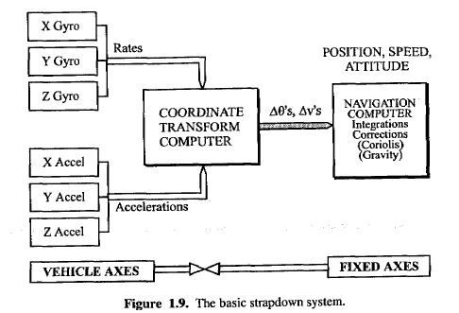

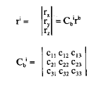
Where c_{ij} are the direction cosines between the j_{th} axis in the inertial frame and the k_{th} axis in the body frame
Advantages:
- Lighter, Simpler, Cheaper and easily configured
- Better withstand vibration and sock
- Highly Reliable
Disadvantages:
- Alignment is difficult
- Need Sensor calibration
- Body Motion- induce unique sensor errors
- Accelerometer Errors
- Need Computer for Computation
3.Explain the operation of Flyby Wire (FBW) flight control system and compare with conventional control system
Motion Sensor Feedback
The motion sensors comprise:
- Rate gyros which measure the angular rates of rotation of the aircraft about its pitch, roll and yaw axes.
- Linear accelerometers which measure the components of the aircraft’s acceleration along these axes.
- The feedback action of these sensors in automatically stabilizing the aircraft.
- Any change in the motion of the aircraft resulting from a disturbance of any sort (e.g., gust) is immediately sensed by the motion sensors
- Then the computer to move the appropriate control surfaces so as to apply forces and moments to the aircraft to correct and suppress the deviation from the commanded flight path.
- An automatic ‘hands-off’ stability is achieved with the aircraft rock steady if the pilot lets go of the control stick.
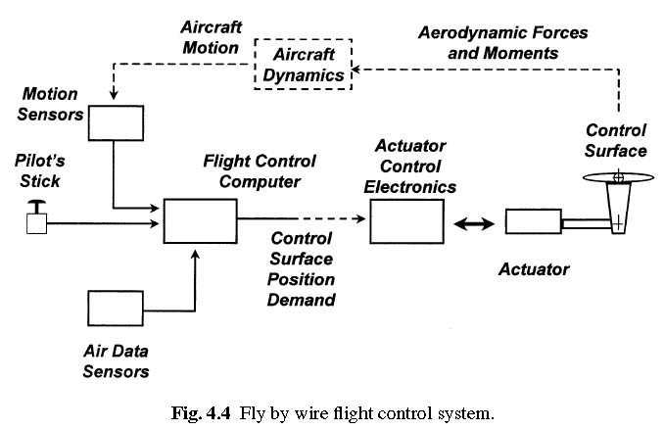
Air Data
- The need for air data information on the airspeed and height is to compensate for the very wide variation in the control surface effectiveness over the aircraft’s flight envelope of height and speed combinations.
- The FBW system is thus supplied with airspeed, height and Mach number in order to adjust or scale the control surface deflections accordingly.
- Totally independent, redundant sources of air data information are required in order to meet the safety and integrity requirements. Generally, quadruplex sources are used.
- The FBW system also requires information on the aircraft incidence angles, that is the local flow angles in the pitch and yaw planes between the airstream and the fuselage datum.
- The pitch incidence angle controls the wing lift and it is essential to monitor that the incidence angle is below the maximum value to ensure that a stall condition is not reached.
High Integrity, Failure Survival Computing System
The flight control computing system must be of very high integrity and have the failure survival capability to meet the flight safety requirements. The tasks carried out by the computing system comprise:
(a) Failure detection.
(b) Fault isolation and system reconfiguration in the event of a failure.
(c) Computation of the required control surface angles.
(d) Monitoring.
(e) Built in test.
Very High Overall System Integrity
- The overall system integrity must be as high as the mechanical control system it replaces.
- The probability of a catastrophic failure must not exceed 10−9/hour for a civil aircraft and 10−7/hour for a military aircraft.
Redundant Configurations
- A well established redundant configuration comprises four totally independent channels of sensors and computers in a parallel arrangement to give the required failure survival capability – such a configuration is referred to as a quadruplex system.
- The four independent channels are then configured to drive a failure survival actuation system with sufficient redundancy such that the overall FBW system of interconnected sensors, computers and actuators can survive any two failures from whatever cause.
Figure 4.26 illustrates the basic quadruplex configuration
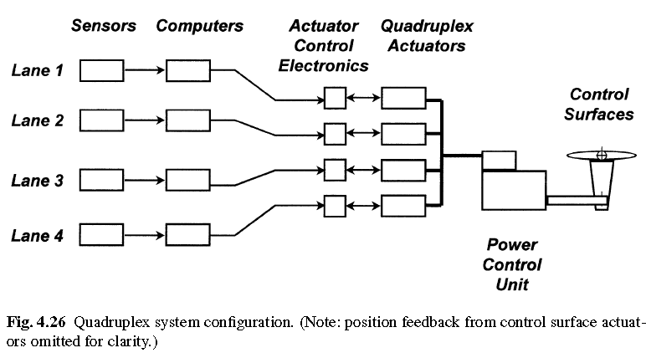
- The integrity of the electrical power supplies and the hydraulic power supplies is absolutely vital and adequate redundancy must be provided so that the system can survive failures in both the electrical and hydraulic power supplies.
- In fact the starting point in the design of any FBW system is the safety and integrity and redundancy levels required of the electrical and hydraulic power supply systems as their integrity dominates the overall FBW system integrity.
- With four totally independent channels, the assumption is made that the probability of three or four channels failing at the same instant in time is negligible.
- Thus if one system fails ‘hard over’ (i.e., demanding maximum control surface movement), the other three parallel ‘good’ channels can over-ride the failed channel.
- However to survive a second failure it is necessary to disconnect the first failed channel, otherwise it would be stalemate – two good channels versus two failed hard over channels so that the control surface does not move – a ‘fail passive’ situation.
- Failures are therefore detected by cross-comparison of the parallel channels and majority voting on the ‘odd man out’ principle.
- The quadruplex system is thus able to survive two failures by majority voting and disconnecting the failed channels, the system degrading to triplex redundancy after the first failure and duplex redundancy after the second failure.
- A third failure results in a fail passive situation, the ‘good’ channel counteracting the failed channel.
The benefits (Advantages) of the fly-by-wire are as follows:
- Flight envelope protection (the computers will reject and tune pilot’s demands that might exceed the airframe load factors);
- Increase of stability and handling qualities across the full flight envelope, including the possibility of flying unstable vehicles;
- Turbulence suppression and consequent decrease of fatigue loads and increase of passenger comfort;
- drag reduction by an optimised trim setting;
- Higher stability during release of tanks and weapons;
- Easier interfacing to auto-pilot and other automatic flight control systems;
- Weight reduction
- Maintenance reduction;
- Reduction of airlines’ pilot training costs
DIRECT MECHANICAL (CONVENTIONAL) CONTROL OF AIRCRAFT
PUSH-PULL RODS SYSTEM
- The linkage from cabin to control surface can be fully mechanical if the aircraft size and its flight envelop allow;
- In this case the hinge moment generated by the surface deflection is low enough to be easily contrasted by the muscular effort of the pilot.
- Two types of mechanical systems are used: push-pull rods and cable-pulley.
- In the first case a sequence of rods link the control surface to the cabin input.
- Bell-crank levers are used to change the direction of the rod routings.
- Vibrations of the rods can introduce oscillating deflections of the surface.

CABLE-PULLEY SYSTEM
- The couples of cables are used in place of the rods.
- In this case pulleys are used to alter the direction of the lines,
- Idlers to reduce any slack due to structure elasticity, cable strands relaxation or thermal expansion.
- Often the cable-pulley solution is preferred, because is more flexible and allows reaching more remote areas of the airplane.

- Explain the elements of Electronic Warfare system
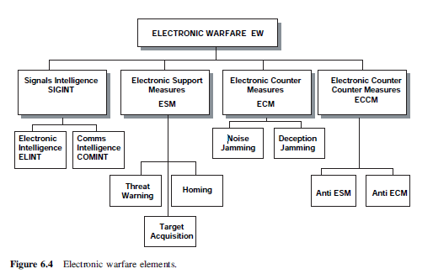
a.SIGNALS INTELLIGENCE (SIGINT)
- Intelligence is collected from a number of different sources to form a strategic picture. These
sources include:
- ELINT or electronic intelligence;
- COMINT or communications intelligence.
- Confirmation of electronic warfare intelligence is usually performed by comparison with local information collection and photographic evidence, including:
- HUMINT or human intelligence;
- IMINT or image intelligence;
- PHOTINT or photographic intelligence.
- The first two items on this list are often gathered by high-flying EW aircraft on long duration patrols, usually flying a patrol on the friendly side of a border and beyond missile engagement range.
b.ELECTRONIC INTELLIGENCE (ELINT)
- Figure 6.6 shows some examples of radar emitters, or systems operating in the radar bands that are likely to be of interest to ELINT collection aircraft. These include:
- Ground-based surveillance radars scanning borders looking for airborne or land-based
intruders and forming a defensive security screen;
- Missile site or anti-aircraft artillery (AAA) radars scanning for threats and preparing to lock on
and to track targets for directing defensive weapons;

- Forward command post radars providing advanced and localised warning of intrusion in order
to direct local defences;
- Land and naval forces operating their own radar systems for detection and target tracking;
- Other fixed-wing aircraft and helicopters operating with their own characteristic radar types.

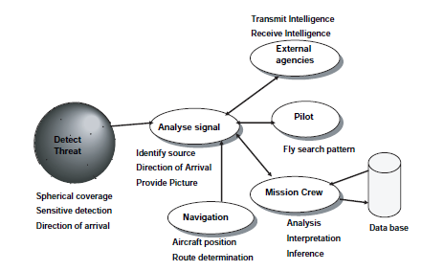
- The antennas are located on the aircraft to provide suitable coverage of the scenario to be monitored and detect an arriving signal and its direction of arrival (DoA).
- The signal is analysed to identify the source and its DoA, and to scan intelligence received from other sources to try to confirm the signal source.
- This is fused with the aircraft navigational data so that a picture can be provided showing the source relative to the ELINT aircraft.
- The crew will interpret the information and provide the information to other operators.
c.Communications Intelligence (COMINT)
- Communications intelligence (COMINT) is gathered by scanning the normal communications frequency bands and locking on to detected transmissions.
- In peacetime it may be possible to receive in clear speech, but this is extremely unlikely in times of tension or during conflict.
- For these reasons the information-gathering aircraft attempts to obtain a position fix on a transmitter and records the activity for later analysis.
- Depending upon the communications frequency, it is not always possible to obtain an accurate fix on a particular platform within a task group.
- However, observation over a period of time allows an overall picture to be built up regarding a potential foe’s force structure and intended electronic order of battle (EoB).
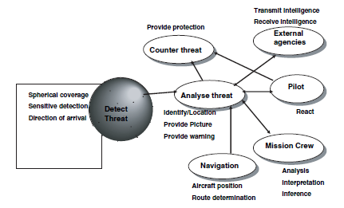

d.Electronic Support Measures (ESM)
- Information on immediate threats is gathered by an electronic support Measures (ESM)system.
- An effective ESM system rapidly identifies the signal band and location and determines
the signal characteristics depending upon a number of discriminators.
- A signal analyser then examines the signal characteristics to identify the type of transmitter and the level of threat posed.
- Even the most cursory of analysis can establish whether the emitter is associated with surveillance, target tracking or target engagement.
- This analysis can compare the signal with known emitter characteristics obtained from an intelligence database or threat library and known signal types confirmed and new emissions identified and categorised.
- Every signal identification is logged with date, time and intercept coordinates, along with the known or
suspected platform type, and the results are stored.
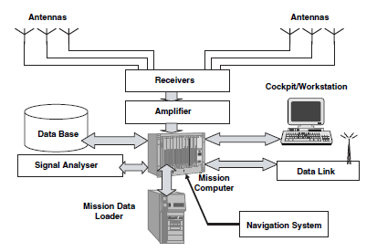
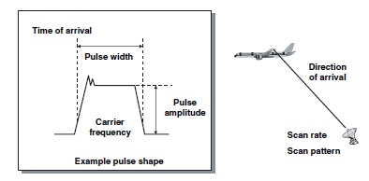
e.ELECTRONIC COUNTERMEASURES
Electronic countermeasures (ECM) and electronic counter-countermeasures (ECCM) take the form of interfering or deceiving the enemy’s radio and radar systems in order to negate their use or, worst of all, compromise their performance
1. Noise Jamming
1. Active noise jamming is often performed by identifying an enemy detection system and broadcasting white
noise at high power levels.
2. For communication systems, noise jamming could employ the broadcast of music or other audio features
designed to deny the use of the particular service.
3. Most jamming transmitters are designed to operate over the range of frequencies expected, and this is
extremely wide given the range of communications devices, search radar and guidance radar types to be
found on the modern battlefield.
4. In the case of radar, the bandwidth covered is often in the range 2–18 GHz. The jammer is most effective if it can be designed to target a specific frequency range or type of threat, in which case the power output is concentrated into a narrow spectrum.
5. Given that a jammer must operate against a wide range of emitters, its power must be spread over an increased spectrum
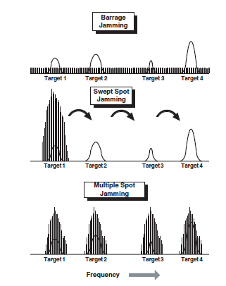
Three different techniques are shown:
1.Barrage jamming. In this example, jamming power is spread across the entire spectrum encompassing the targets. This results in a very low jamming power density (W/MHz) to the point that none of the targets is adversely affected.
2. Swept spot jamming. Swept spot jamming concentrates sufficient power in a narrow bandwidth to negate each target. The jammer switches to each of the targets in turn but is only present for a low-duty cycle. This may suffice if the target receiver saturation and automatic gain control capabilities are modest but will not suffice for higher-performance systems.
3. Multiple-Spot Jamming. Multiple-spot jamming divides the energy between the targets, effectively jamming them in parallel rather than sequentially. This requires a more sophisticated jamming transmitter.
2.Deception Jamming
Deception jamming employs more sophisticated techniques to negate the performance of the radar. Some typical techniques used to break the radar-tracking loops are:
1. False target generation. If the modulating characteristics of the target radar are known, it is possible to transmit pulses that will appear as multiple targets in the victim radar. Hence, by using the jamming transmitter with diligence and transmitting replica pulses after a time delay, these false, multiple, spurious targets will appear in subsequent radar range sweeps. An intelligent radar operator should realise that his radar is being deceived but may have a problem in deciding which of the multiple returns is the correct one.
2. Range gate stealing. This is a variation on the technique described above where one false pulse is generated that appears in the victim’s radar at the same range as the jammer. It is then possible to capture the range gate with the artificial pulse; in particular, if the false pulse appears to be stronger than the original in the victim receiver, it is possible to ‘steal’ the range gate by progressively altering the false range. If desired, the range gate may be left on a false value or moved off to coincide with clutter, whereupon the target lock will
be lost.
3. Angle track breaking. Similarly, there are ways of breaking the angle track mechanism, especially if the tracking mechanism of the victim radar is well understood. For example, in a conscan radar, angle track may be broken if the jamming signal is modulated at a frequency that approaches that of the conscan modulation frequency of the subject radar. This presupposes that the angle tracking method and conscan rate are known, which may not be the case in a wartime situation. Other simple ways of angle deception include terrain bounce, cross-eye, cross-polarisation and double cross.
4. Velocity gate stealing. This is similar to range gate stealing except that the incident signal is re-radiated back to the victim radar, initially without modification. Progressively the reradiated signal is amplified and masks the original Doppler component upon which the velocity gate is centred. The deceiving radar may then steal the velocity gate in a similar manner to the range gate stealer described above.

5. Explain the Communication Systems

- High Frequency
- High frequency (HF) covers the communications band between 3 and 30 MHz and is a very
common communications means for land, sea and air.
- The utilised band is HF SSB/AM over the frequency range 2.000–29.999 MHz using a 1 kHz (0.001 MHz) channel spacing.
- The primary advantage of HF communications is that this system offers communication beyond
the line of sight.
- The sky wave method of propagation relies upon single- or multiple-path bounces between
the earth and the ionosphere until the signal reaches its intended location.
- The behaviour of the ionosphere is itself greatly affected by radiation falling upon the earth, notably solar radiation.
- Times of high sunspot activity are known adversely to affect the ability of the ionosphere as a reflector.
- It may also be affected by the time of day and other atmospheric conditions.
- The sky wave as a means of propagation may therefore be severely degraded by a variety of conditions, occasionally to the point of being unusable.
- The ground wave method of propagation relies upon the ability of the wave to follow the curvature of the earth until it reaches its intended destination.
- As for the sky wave, the ground wave may on occasions be adversely affected by atmospheric conditions.
- Therefore, on occasion, HF voice communications may be corrupted and prove unreliable, although HF data links are more resistant to these propagation upsets, as described below.
- HF communications are one of the main methods of communicating over long ranges between air and ground during oceanic and wilderness crossings when there is no line of sight between the aircraft and ground communications stations.
- For reasons of availability, most long-range civil aircraft are equipped with two HF sets with an increasing tendency also to use HF data link if polar operations are contemplated.
- Very High Frequency
- Voice communication at very high frequency (VHF) is probably the most heavily used
method of communication used by civil aircraft, although ultrahigh frequency (UHF) is generally preferred for military use.
- The VHF band for aeronautical applications operates in the frequency range 118.000–135.975 MHz with a channel spacing in past decades of 25 kHz (0.025 MHz).
- In recent years, to overcome frequency congestion, and taking advantage of digital radio technology, channel spacing has been reduced to 8.33 kHz (0.00833 MHz) which permits 3 times more radio channels in the available spectrum. Some parts of the world are already operating on the tighter channel spacing – this will be discussed in more detail later in the chapter in the section on global air transport management (GATM).
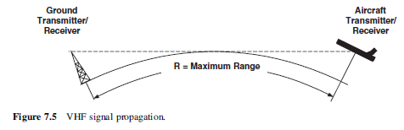
Limitations of VHF:
- VHF signals will only propagate over line of sight.
- This line-of-sight property is affected by the relative heights of the radio tower and aircraft.
C.SATELLITE COMMUNICATION
- Satellite communications provide a more reliable method of communications using the
International Maritime Satellite Organisation (INMARSAT) satellite constellation which was originally developed for maritime use.
- Now satellite communications, abbreviated to SATCOM, form a useful component of aerospace communications.
- The aircraft communicates via the INMARSAT constellation and remote ground earth station by means of C-band uplinks and downlinks to/from the ground stations and L-band links to/from the aircraft.
- In this way, communications are routed from the aircraft via the satellite to the ground station and on to the destination.
- Conversely, communications to the aircraft are routed in the reverse fashion.
- Therefore, provided the aircraft is within the area of coverage or footprint of a satellite,
communication may be established.
- The airborne SATCOM terminal transmits on frequencies in the range 1626.5– 1660.5 MHz and receives messages on frequencies in the range 1530.0–1559.0 MHz.
- Upon power-up, the radio-frequency unit (RFU) scans a stored set of frequencies and locates the transmission of the appropriate satellite.
- The aircraft logs on to the ground earth station network so that any ground stations are able to locate the aircraft.
- Once logged on to the system, communications between the aircraft and any user may begin.
- The satellite to ground C-band uplink and downlink are invisible to the aircraft, as is the remainder of the earth support network.
Limitations:
- low grazing angles, coverage begins to degrade beyond 80̊⁰north and 80⁰ south and fades
completely beyond about 82⁰
